Name:
Date
Period

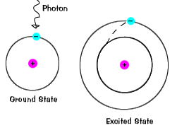
Flame Test Lab Experiment: What color does it burn?

Background Information: Atoms have atomic orbitals with electrons and when the atoms/elements are heated, the electrons get excited. They fall back to ground state (their original position) when the electrons are no longer excited. Depending on how far they fall, their wavelengths may vary and different colors may be visible.

Problem: What happens to an atom’s electrons when we burn them and how can you tell electrons are moving?
Hypothesis: I believe__________ will be seen when atom’s electrons are burned due to _________. I may see colors when atoms are burned because________________.
Materials:
- Calcium chloride
- Lithium chloride
- Strontium chloride
- Potassium chloride
- Sodium chloride
- Copper (II) chloride

Procedure:

- Take a flame/propane can and make a flame.
- Dip a cotton swab in some distilled water.
- Dip the cotton swab in one of the chemical powders.
- Stick the cotton swab in the fire.
- Record any colors observed.
- Collect the cotton swabs and waste material for proper disposal.

Results:

 | Chemical | Flame Color
1 | Calcium chloride
2 | Lithium chloride
3 | Strontium chloride
4 | Potassium chloride
5 | Sodium chloride
6 | Copper (II) chloride

Conclusion:

