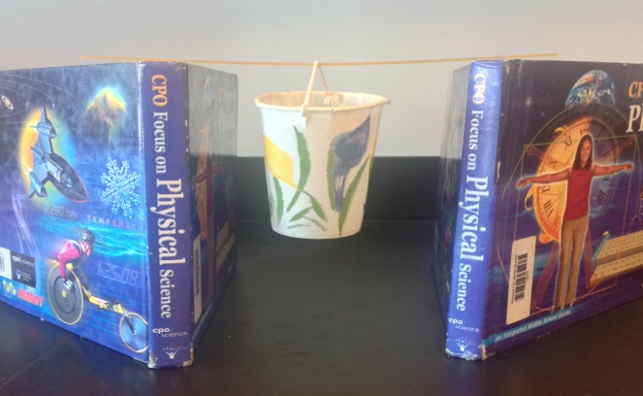
The Spaghetti Experiment!
Problem: How does the length of a spaghetti bridge affect the number of pennies the bridge will support?
Hypothesis: As the bridge _____________
(increases/decreases)
in length, the number of pennies the

bridge will support ______________.
(increases/decreases)
Independent Variable (tested/change): _____________________________
Dependent Variable (data collected/measurements):_________________________
Materials:
ruler two books paper cup with handle
75 pennies 9 strands of spaghetti
Follow the procedures to set up your spaghetti experiment:
1. Use the ruler to place the two books 10 cm apart.
2. Gently hang the cup from one strand of spaghetti in the middle.
3. Place the one strand of spaghetti on top of the books to form a bridge. The cup should be hanging down between the stacks of books like a bucket.
4. One at a time, add pennies to the cup until the spaghetti breaks.
5. Record the number of pennies needed to break the spaghetti in Data Table 1.
6. Repeat this procedure 2 times and record the number of pennies in the data table.
7. Now use the ruler to place the stacks of books 15 cm apart.
8. Repeat the above procedure three times and record the number of pennies in the data table.
9. Finally, use the ruler to place the stacks of books 20 cm apart.
10. Repeat the above procedure three times and record the number of pennies in the data table.
11. Cleanup - be sure that all pieces of spaghetti are placed in the trashcan - not in the sinks or on the floor!!!

Data collection:
Record your observations on the data table. Once you have calculated the averages, graph your data. (Use proper labels in the graph!!!)
Trial Number | Number of pennies at 10 cm | Number of pennies at 15cm | Number of pennies at 20 cm
1
2
3
Average
Graph the averages in the table above. Include a graph title and label the IV and the DV.

Questions:
Answer all questions in complete sentences in your notebook!!!

1. List 3 things from the experiment that you kept the same (control variable).

2. How does the length of the bridge affect the number of pennies needed to break the spaghetti?

3. Explain why different groups of students might get different results? List 3 possible errors?

4. Suppose you were given spaghetti with different thickness. Would your results be the same? Explain why or why not?

5. How would your results be affected if you used a mixture of coins (pennies, nickels, dimes, and quarters) instead of just pennies?

6. Why is it important to test just one independent variable at a time? (Think about if you compared the length of the spaghetti and the thickness of the spaghetti at the same time.)

7. Now that you have analyzed your data, does the data support or reject your hypothesis? Explain (use your data).

